**SIGMA-INVPLUS**

**Automation Test Strategy**

Systems Plus Solutions

## 

Table of Contents

Document Control 3

Scope and Objective 4

Agreed Points 5

Test Environment 5

Test Estimation 5

Testing measurements and metrics 6

Test Team 7

Test Deliverables 7

Risks and mitigation 7

Communication and status reporting 7

Constraints: NA 7

## Document Control

**Document Detail**

|  |  |
| --- | --- |
| Title: | SIGMA-INVPLUS Automation Test Strategy |
| Version: | 1.00 |
| Date: | 19 Sep 2016 |
| Electronic File Name: |  |
| Electronic File Location: | link |
| Author: | Vinayak B Jadhav |
| Contributors: | Harshad, Soniya |

**Change Control**

|  |  |  |  |
| --- | --- | --- | --- |
| Issue Date | Version | Details | Author |
| 19th Sep 2016 | 1.00 | Test Strategy document | Vinayak |
|  |  |  |  |
|  |  |  |  |
|  |  |  |  |
|  |  |  |  |

## Scope and Objective

The Automation Test Strategy document describes approach towards Business Process testing SIGMA INVPLUS Web Application, Develop BPT Automation scripts for approved scenarios and perform Automation execution

**Scope of Project**

* Automation test script development for approved BPT (Smoke) cases with Regression suite
* oExecution of BPT cases, Regression suite through Automation testing.

**Performance benchmark**

* Page should not flicker on page load or later
* Page should get load with in “5-7” seconds
* Reports should get generated within “7-10” seconds for “40” number of users
* Analysis reports e.g. Accrual Calendar may take more time to load
* Upload/calculations/data transfer (process) should not get more than “12-15” seconds.
* Maximum number of users is 40.
* Performance testing should be done on Client Test site on their server

**Out of Scope**

* GUI testing & Unit level of testing (field level requirement)
* Manual Testing
* Compatibility Testing using Automation test script of Selenium web driver
* Responsive Testing & Mobile application testing is not in Scope
* Authentication with Active directory is not in scope
* Verifying SSRS reports through automation scripts (not feasible)

**Agreed Test type**

* Integration Testing
* System/Functional Testing
* Business Process Testing
* Smoke testing Automation test script of Selenium web driver : On Code freeze environment

QET will develop Manual Test case & Automation scenarios parallel to development & submit test case for BA Review and send reviewed test cases to developer for execution, this approach will not only cover unit testing as well as any not implemented item would also be captured & catered, thus defect prevention technique is used.

## Test Environment

* OS: System plus Environment
* Base Web Browser: IE 8,

## Automation Test Scenarios

Estimations/effort are depend on number of Screens (count), if it increases overall effort

|  |  |
| --- | --- |
| **STAGE** | **Automation Test Scenarios** |
| 1 | Create Customer |
| 2 | Create supplier |
| 3 | Create Item Type Master |
| 4 | Create Item Master ( service and Material) |
| 5 | Create Item Group Master |
| 6 | Add Branch A & Branch B with stores |
| 7 | Open Stock Transfer > Opening Balance of created item. |
|  |  |
|  | **InterBranch Stock Transfer : (Material and Service) , Chargeable and Non Chargeable** |
| 8 | Perform IBT : IOF Interbranch - > DN Interbranch - > DC Interbranch - > GRN Interbranch |
|  |  |
|  | **Regular Flow : IOF/SOF (Material and Service) Item 20 (chargeable and Non chargeable) > Replacement 2 > Return 2 > Reject 2** |
| 9 | A > Perform Regular flow : IOF -> SOF -> PO - > GRN (PO) -> DN - > DC -> Invoice -> Payment |
| B > Perform Replacement flow : IOF Replacement -> DN Replacement - > GRN Against Goods Replacement (reg DN + Rep DN) |
| C > Perform Regular Return flow : After DC of Flow A -> GRN Goods Return (against DC of "A" flow) [Credit Note Yes] |
| D > Perform Regular Credit Note flow : After GRN of Flow C - > Credit Note -> IOF -> SOF -> DN - > DC -> Invoice -> Payment against Credit Note |
| E > Perform Regular Reject flow : After GRN of Flow A - > DN Reject (against GRN[verbal, PO, Return] of Flow A ) > DC (reject) |
|  |  |
| 10 | A> Perform Regular flow : IOF -> PO - > GRN (PO) -> DN - > DC -> Invoice -> Payment |
| B > Perform Replacement flow : IOF Replacement -> DN Replacement - > GRN Against Goods Replacement (reg DN + Rep DN) |
| C > Perform Regular Return flow : After DC of Flow A -> GRN Goods Return (against DC of "A" flow) [Credit Note Yes] |
| D > Perform Regular Credit Note flow : After GRN of Flow C - > Credit Note -> IOF -> PO - > GRN (PO) -> DN - > DC -> Invoice -> Payment against Credit Note |
| E > Perform Regular Reject flow : After GRN of Flow A - > DN Reject (against GRN[verbal, PO, Return] of Flow A ) > DC (reject) |
|  |  |
| 11 | A > Perform Regular flow : IOF -> GRN (Verbal) -> DN - > DC -> Invoice -> Payment |
| B > Perform Replacement flow : IOF Replacement -> DN Replacement - > GRN Against Goods Replacement (reg DN + Rep DN) |
| C > Perform Regular Return flow : After DC of Flow A -> GRN Goods Return (against DC of "A" flow) [Credit Note Yes] |
| D > Perform Regular Credit Note flow : After GRN of Flow C - > Credit Note -> IOF -> GRN (Verbal) -> DN - > DC -> Invoice -> Payment against Credit Note |
| E > Perform Regular Reject flow : After GRN of Flow A - > DN Reject (against GRN[verbal, PO, Return] of Flow A ) > DC (reject) |
|  |  |
| 12 | A > Perform Regular flow : IOF -> DN - > DC -> Invoice -> Payment |
| B > Perform Replacement flow : IOF Replacement -> DN Replacement - > GRN Against Goods Replacement (reg DN + Rep DN) |
| C > Perform Regular Return flow : After DC of Flow A -> GRN Goods Return (against DC of "A" flow) [Credit Note Yes] |
| D > Perform Regular Credit Note flow : After GRN of Flow C - > Credit Note -> IOF -> DN - > DC -> Invoice -> Payment -> Payment against Credit Note |
| E > Perform Regular Reject flow : After GRN of Flow A - > DN Reject (against GRN[verbal, PO, Return] of Flow A ) > DC (reject) |
|  |  |
| 13 | A > Perform Regular flow : SOF ->DN - > DC -> Invoice -> Payment |
| B > Perform Replacement flow : IOF Replacement -> DN Replacement - > GRN Against Goods Replacement (reg DN + Rep DN) |
| C > Perform Regular Return flow : After DC of Flow A -> GRN Goods Return (against DC of "A" flow) [Credit Note Yes] |
| D > Perform Regular Credit Note flow : After GRN of Flow C - > Credit Note -> SOF ->DN - > DC -> Invoice -> Payment against Credit Note |
| E > Perform Regular Reject flow : After GRN of Flow A - > DN Reject (against GRN[verbal, PO, Return] of Flow A ) > DC (reject) |
|  |  |
| 14 | A > Perform Regular flow : SOF -> PO - > GRN (PO) -> DN - > DC -> Invoice -> Payment |
| B > Perform Replacement flow : IOF Replacement -> DN Replacement - > GRN Against Goods Replacement (reg DN + Rep DN) |
| C > Perform Regular Return flow : After DC of Flow A -> GRN Goods Return (against DC of "A" flow) [Credit Note Yes] |
| D > Perform Regular Credit Note flow : After GRN of Flow C - > SOF -> PO - > GRN (PO) -> DN - > DC -> Invoice -> Payment against Credit Note |
| E > Perform Regular Reject flow : After GRN of Flow A - > DN Reject (against GRN[verbal, PO, Return] of Flow A ) > DC (reject) |
|  |  |
| 15 | A> Perform Regular flow : SOF -> GRN (Verbal) -> DN - > DC -> Invoice -> Payment |
| B > Perform Replacement flow : IOF Replacement -> DN Replacement - > GRN Against Goods Replacement (reg DN + Rep DN) |
| C > Perform Regular Return flow : After DC of Flow A -> GRN Goods Return (against DC of "A" flow) [Credit Note Yes] |
| D > Perform Regular Credit Note flow : After GRN of Flow C - > SOF -> GRN (Verbal) -> DN - > DC -> Invoice -> Payment against Credit Note |
| E > Perform Regular Reject flow : After GRN of Flow A - > DN Reject (against GRN[verbal, PO, Return] of Flow A ) > DC (reject) |
|  |  |
|  | **Stand By Given ( Material, Service, Chargeable and Non chargeable)** |
| 16 | Perform Stand By Given : IOF (Stand By Given) - > DN (Stand By Given) - > DC (Stand By Given) -> DC (Stand By Given) - > GRN against Stand By return |
|  | **Stand By Received ( Material, Service, Chargeable and Non chargeable)** |
| 17 | Perform Stand By Received : PO (stand By taken) - > GRN (Stand By received) - > DN (Stand By return to) - > DC (Stand By return to) |

|  |  |  |  |  |  |  |  |  |  |  |
| --- | --- | --- | --- | --- | --- | --- | --- | --- | --- | --- |
| **Effort Estimation Manual task (KT & Test strategy effort included)** | | | | | | | | | | |
| **Modules/Task** | **Count** | **KT** | **Test Strategy** | **TC dev** | **Auto** | **Manual 1st Edge** | **Manual 2nd Edge** | **Smoke & performance on final** | **Manual Effort Total** |
| Masters | 14 | NA | NA | 5.25 | 5.25 | 3.5 | 2.1 | 2 | 18.1 |
| Transactions | 2 | NA | NA | 2 | 2 | 1.5 | 0.9 | 0 | 6.4 |
| Reports | 13 | NA | NA | 3.25 | 2.5 | 2.5 | 1.5 | 0 | 9.75 |
| File Import | 2 | NA | NA | 0.5 | 0.5 | 0.5 | 0.3 | 0 | 2.3 |
| Upload | 2 | NA | NA | 0.5 | 0 |
| Performance | 4 | NA | NA | NA | 1 | NA | NA | 1 | 2 |
| Test Strategy | NA | 1 | NA | NA | NA | NA | NA | NA | 1 |
| KT | NA | NA | 1 | NA | NA | NA | NA | NA | 1 |
| Total | 33 | 1 | 1 | 11.50 | 11.25 | 8.00 | 4.80 | 3.00 | **40.55** |

|  |  |  |  |  |  |  |  |  |  |  |  |  |  |  |
| --- | --- | --- | --- | --- | --- | --- | --- | --- | --- | --- | --- | --- | --- | --- |
| **Automation execution effort ( doesn’t require manual effort)** | | | | | | | | | | | | | | |
| **Modules** | **Count** | **Auto 1st Chrome 50** | **Auto 1st Chrome 52** | **Auto 1st Chrom 54** | **Auto 1st IE 10** | **Auto 1st Firefox 46** | **Auto 1st Firefox 48** | **Auto 2nd Chrome 50** | **Auto 2nd Chrome 52** | **Auto 2nd Chrom 54** | **Auto 2nd IE 10** | **Auto 2nd Firefox 46** | **Auto 2nd Firefox 48** | **Total** |
| Masters | 12 | 0.5 | 0.5 | 0.5 | 0.5 | 0.5 | 0.5 | 0.5 | 0.5 | 0.5 | 0.5 | 0.5 | 0.5 | 6 |
| Transactions | 4 | 0.5 | 0.5 | 0.5 | 0.5 | 0.5 | 0.5 | 0.5 | 0.5 | 0.5 | 0.5 | 0.5 | 0.5 | 6 |
| Workflow | 5 |
| Reports | 13 | 0.25 | 0.25 | 0.25 | 0.25 | 0.25 | 0.25 | 0.25 | 0.25 | 0.25 | 0.25 | 0.25 | 0.25 | 3 |
| File Import | 2 | 0.25 | 0.25 | 0.25 | 0.25 | 0.25 | 0.25 | 0.25 | 0.25 | 0.25 | 0.25 | 0.25 | 0.25 | 3 |
| Upload | 2 |
| Performance | 4 | NA | NA | NA | NA | NA | NA | NA | NA | NA | NA | NA | NA | 0 |
| Total | 38 | 1.5 | 1.5 | 1.5 | 1.5 | 1.5 | 1.5 | 1.5 | 1.5 | 1.5 | 1.5 | 1.5 | 1.5 | **18** |

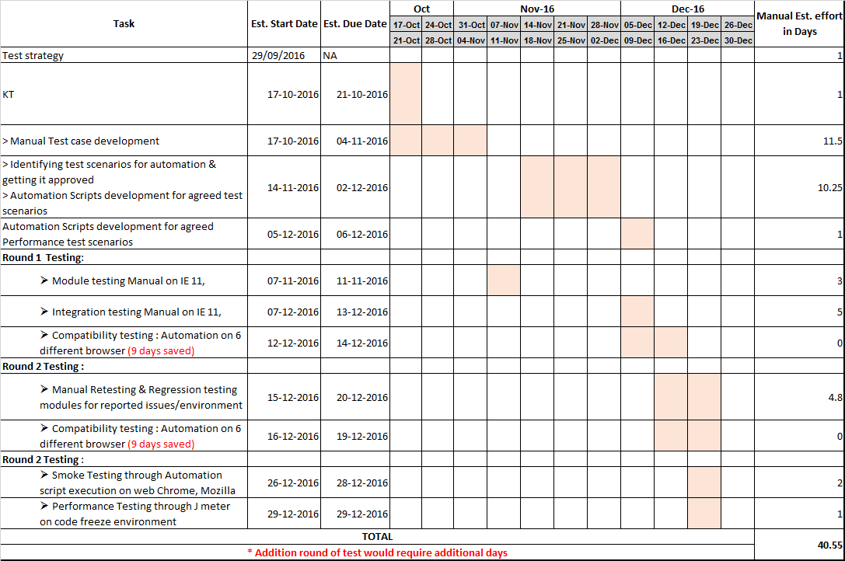

## Testing measurements and metrics

|  |  |  |
| --- | --- | --- |
| **Measurement** | **Required**  **Yes/No** | **Remarks** |
| Number of test iterations planned | Yes | * Round 1 : Automation execution of BPT cases * If issue found : Round 2: Retest, Regression Testing. |
| Number of scenarios per system process/modules | Yes | Defined by the QET team |
| Number of other application systems in the systems integration test | No |  |
| Required online response time for critical modules | No |  |
| Number of end users required for the stress test | No |  |
| Batch nightly window response time | No |  |

## Test Team

|  |  |
| --- | --- |
| Name | Role |
| Vinayak Jadhav | QET : Verification & validation Tester |
| Prasad Kadam | QET : Verification & validation Tester |
| Narendra Nikam | QET : Verification & validation Tester |

## Test Deliverables

|  |  |  |
| --- | --- | --- |
| **Deliverables type** | **Required**  **Yes/No** | **Remarks** |
| Testing Strategy | Yes | QET |
| System Process Test Model | No |  |
| System Test Plan | Yes | Test strategy |
| System Test Environment | No |  |
| System Test Results | Yes | HTML Reports of Automation execution |
| Systems Integration Test Cases | Yes | Automation Excel file |
| Systems Integration Test Results | Yes | Automation reports |
| Service Desk Set up | No | Already had |
| Excel File Reference | No |  |

## Risks and mitigation

* Identified testing risks and their associated contingency plans include the following:

|  |  |  |  |  |
| --- | --- | --- | --- | --- |
| ID | Risk Statement | Probability | Impact | Mitigation |
| 1 | Availability of Additional machine for automation execution | High | Critical |  |
|  |  |  |  |  |

## Communication and status reporting

|  |  |  |
| --- | --- | --- |
|  | **Required**  **Yes/No** | **Remarks** |
| Service Desk | No |  |
| Weekly (WRF) Update | Yes |  |
| Monthly Update | No |  |
| Email | Yes |  |
| QA Approval email | Yes |  |

## Constraints: NA